Name __________________________________________ Core _______ Date __________________________

Tops in Topography
Comparing Landforms and Natural Features
Background: Whether you are looking for spacious skies, amber waves of grain, purple mountain majesties, or fruited plains – America the beautiful seems to have them all!

Task: Your task is to complete a booklet of information on the United States topography, then to compare the features to the “tops” in the world.

Procedure:
Parent Signature _______________________________________

Preview the project and get a Parent Signature.
- Select a feature in which to be the expert.
- Complete the 3 U.S. natural features’ charts.
- Use the data to complete your Tops in Topography Booklet.
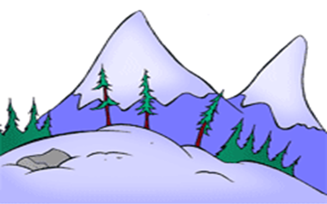
Highest U.S. Mountains | Height (m)
Mt. McKinley
Mt. Whitney
Mt. Elbert
Mt. Rainier
Gannett Peak
Largest U.S. Lakes | Area (sq. km)
Lake Superior
Lake Huron
Lake Michigan
Lake Erie
Lake Ontario
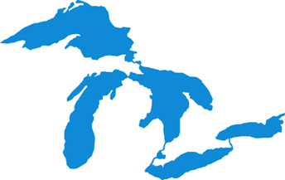

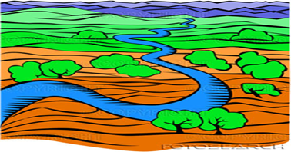
Longest U.S. Rivers | Length (km)
Missouri
Mississippi
Yukon
Rio Grande
Arkansas

- Cover – Design a COVER for your booklet.
- Page 1 – Locate and label the 15 features on a U. S. MAP.
  - Add a key, compass rose, and title.
- Page 2 – Choose one of the 15 U. S. features and develop a FUN FACT PAGE.
- Page 3 – Prepare 2 BAR GRAPHS featuring each U. S. category – mountains, rivers, and lakes.
  - Create one bar graph by hand and one graph using Sheets for each category.
- Page 4 – Complete THE AMAZING CRUST sheet.
- Page 5 – Research to find the TOP FIVE WORLD FEATURES for each category.
  - Display your data in a table using Docs; then add color and graphics
Name __________________________________________Core _______ Date ______________________
Partners ______________________________________________________________________________
Expert in _______________________________

Tops in Topography
Assessment
Requirement Points Self Teacher
Possible Score Score
Back Cover
Names/Expert
Core
Date
Project Name
Front Cover 15 _____ _____
- has a catchy title
- supports the topic theme
- is creative and highly interesting

Page 1 – 15 Features on the US Map 20 _____ _____
- are located accurately
- are labeled properly
- are illustrated neatly
- includes key, compass rose, title

Page 2 – Fun US Fact Page 15 _____ _____
- has feature’s name and location
- includes 5 fun facts
- is designed with color and graphics

Page 3 – 6 Bar Graphs of the US Features 20 * _____ _____
(3 done by hand and 3 using Sheets)
- have appropriate titles and labels
- use space wisely and plotted data accurately
- are attractive and easy to understand

Page 4 – Amazing Crust Sheet 20 _____ _____
- is completed accurately
- shows metric units
- is colored attractively

Page 5 – 5 Top World Features in each Category 10 * _____ _____
- are displayed in a Docs table
  - accurately using metric units
  - with feature’s names, size, location
- are enhanced with color and graphics

TOTAL 100 _____ _____
* Individual Score
All pages are to be completed in FINAL COPY FORM following the PFCA’s.

Extra Credit – Trekking Across the United States

