Name Date

Practice A

4.4

Find and label each pair of points in a coordinate plane. Find the length of the line segment connecting the points.

1.  2.  3. 

_________ __________ __________

Draw the polygon with the given vertices in a coordinate plane.

4.  5. 

6.  7. 

Find the perimeter and area of the polygon with the given vertices.

Hint: You may draw it on your coordinate grid to help.

8.  9. 

Perimeter: __________ Perimeter: __________

Area: ______________ Area: _______________

10. You design a courtyard using a coordinate plane. You plot the vertices of the courtyard at *F*(1, 0), *G*(5, 8), and *H*(1, 8). The coordinates are measured in yards.

a. What is the shape of the courtyard? ____________________

b. What is the area of the courtyard? ____________

Draw a polygon with the given conditions in a coordinate plane.

11. a rectangle with a perimeter of 20 units

12. a square with a perimeter of 16 units

13. a square with an area of 25 square units

14. a triangle with an area of 6 square units

15. The coordinate plane shows three vertices of a parallelogram. Find two possible points that could represent the fourth vertex.

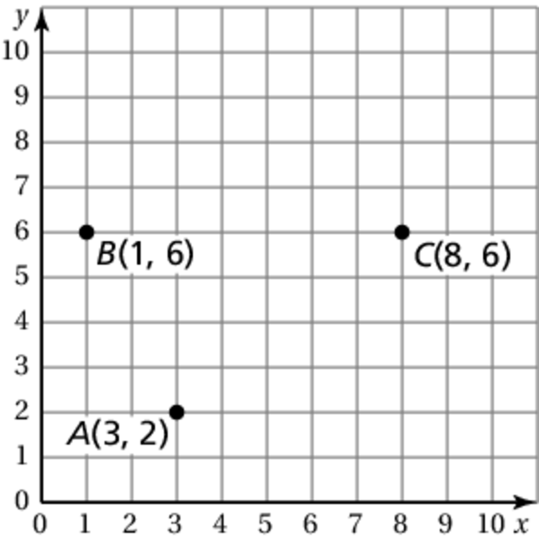

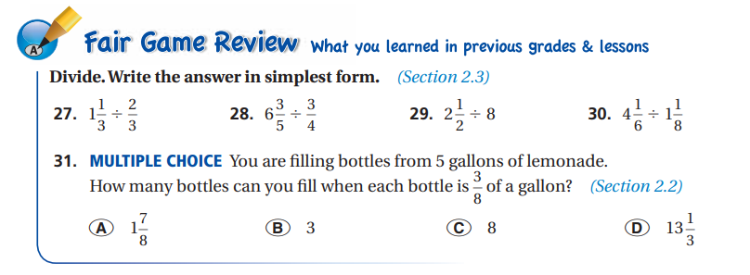

**Remember: Keep, Change, Flip** and **Change mixed numbers to improper fractions first!**

27. ________ 28. ________ 29. ________ 30. ________