Name Date

Practice A

4.3

Find the area of the trapezoid. A = ½ h(b1 + b2)

1.  2. 

__________________ ___________________

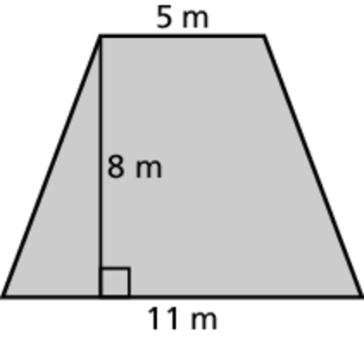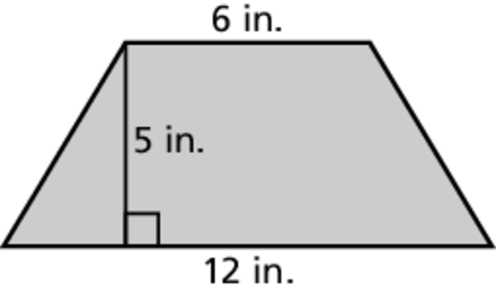 3. 4.

________________ ___________

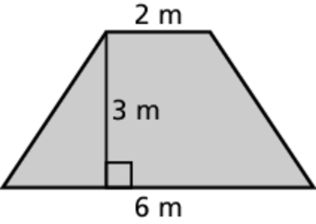5. Describe and correct the error in finding   
the area of the trapezoid.



TURN OVER →

Find the area of the trapezoid.

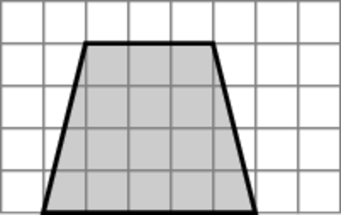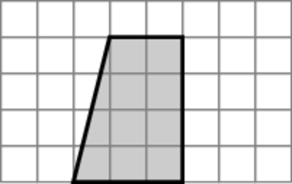 6. 7.

_____________ ____________

8. The triangle and the trapezoid have the same area. What is the length  of the triangle?





