Name Date

Practice A

4.1

Find the area of the parallelogram. A = b*h

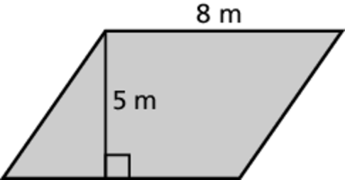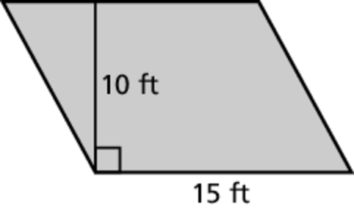 1. 2.

____________ ______________

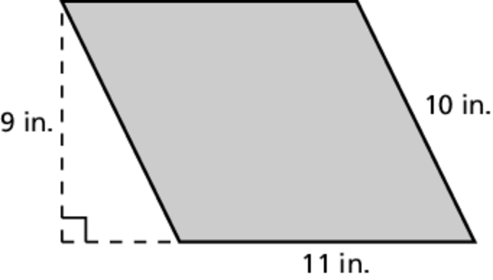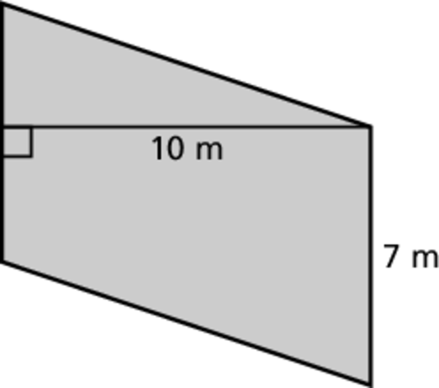 3. 4.

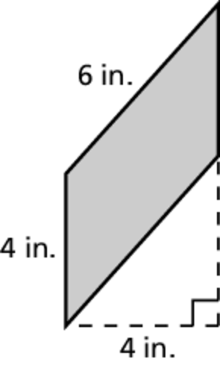 ______________ ______________



5. Describe and correct the error in finding  
the area of the parallelogram.

Find the area of the parallelogram.

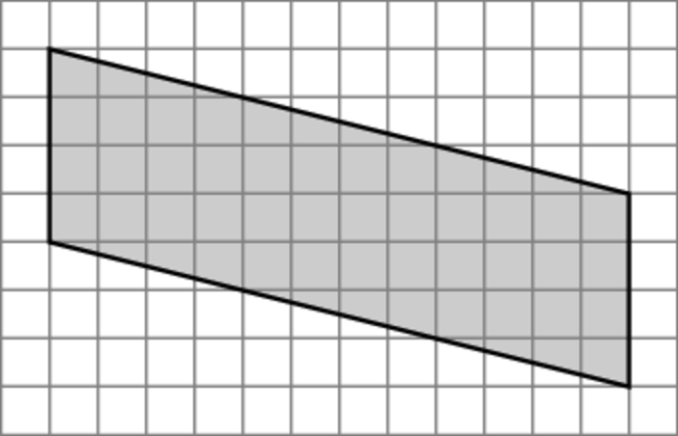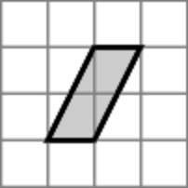 6. 7.

__________ ______________

8. A square has side length 6 inches. A parallelogram has a base of 6 inches. The area of the square is equal to the area of the parallelogram. What is the height of the parallelogram?

____________________

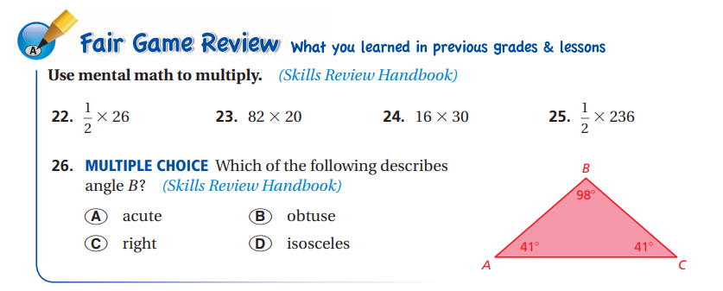

22. ________ 23. ________ 24. ________ 25. ________